Webster County Economic Development Authority
Request for Proposal (RFP)

ISP/Private Partner(s) for Design Assistance, Construction, Deployment, Operation, and Maintenance of Broadband Network

Webster County Broadband Initiative

Attn: Chris Graham

Webster County EDA

PO Box 4

Webster Springs, WV 26288

Date: June 3, 2020

REQUEST FOR PROPOSALS
WEBSTER COUTY BROADBAND INITIATIVE

The Webster County Economic Development Authority (Webster County EDA) will accept sealed proposals to enable the County to identify one or more ISP (Internet Service Provider)/Private Partners interested in construction, deployment, operation and maintenance of Broadband Internet Network in key target areas of Webster County, WV as specified.

RFP documents and specifications may be obtained in person from the Webster County EDA PO Box 4, Webster Springs, WV 26288. A copy of the RFP documents can also be downloaded from the EDA’s web site at https://www.websterwv.com/ Inquiries may be made by calling (304) 847-2145.

All interested respondents must submit a Letter of Intent to the Webster EDA on or before Friday, June 26th, 2020 at 2:00 P.M. (local time). Sealed RFP’s must be submitted to the Webster County EDA PO Box 4, Webster Springs, WV 26288 on or before Friday, July 24th, 2020 at 2:00 P.M. (local time). All respondents are required to submit five (5) copies and an electronic copy or link of their RFP’s documents at the time of submission. All RFP’s submitted should be enclosed in a sealed envelope and clearly marked “Broadband Network RFP” on the outside of the envelope. Any RFP’s received after the time due will not be considered and shall be retained as documentation for the RFP file.

The Webster County EDA reserves the right to accept or reject any or all RFP’s, to cancel this request for information and to waive technicalities in any part thereof deemed to be in the best interest of Webster County.

By Order of the Board

Chris Graham
Webster County EDA
PO Box 4
Webster Springs, WV 26288
wcda@websterwv.com

TABLE OF CONTENTS

- INTRODUCTION 4
- PROJECT DESCRIPTION 4
- GOALS OF THIS PROCUREMENT 5
- PERFORMANCE EXPECTATIONS 5
- ORGANIZATION OF THE PROPOSAL 6
- SUBMITTAL OF THE PROPOSAL 8
- PROPOSAL ACCEPTANCE 9
- EDA REQUIREMENTS 9
- EDA CRITERIA FOR SELECTING AN ISP/PRIVATE PARTNER 10
- SELECTION PROCESS 10
- LIMITATIONS 11
- ATTACHMENTS 11

WEBSTER COUNTY BROADBAND INITIATIVE:
PHASE II CONSTRUCTION
REQUEST FOR PROPOSALS

INTRODUCTION & PROJECT PURPOSE
The Webster County EDA (“EDA”) is seeking proposals from qualified respondents interested in providing the services as described in this request for proposals (“RFP”). The primary purpose of the project is to deploy a fiber and/or fixed wireless solution that will provide the businesses and residents of the project areas with broadband services of at least 25/3 Mbps.

PROJECT DESCRIPTION
The proposed Broadband project will bring a cost effective broadband network into the heart of the Webster County, including Webster Springs, Parcoal, Curtin, Cowen, Bolair, Upper Glade and Camden-on-Gauley. This procurement process, as mandated by the requirements for federally funded publicly owned projects, is being completed to procure a qualified provider for the purpose of installing a “Middle-Mile” Licensed GigE Microwave on existing towers to bring the internet close to the cities and towns located in the proposed service area. The procured provider will also use fixed wireless and fiber to deliver high speed internet to the local businesses and residents of the proposed project area.

The project will consist of three primary towers each all 180 feet in height, the primary towers include:
• Existing DHHR tower near Webster Springs
• Existing DHHR tower near Craigsville
• New tower to be constructed near Cowen

In addition to the three primary towers, the proposed project will also include six (6) relay towers all 90 feet in height. The relay towers will be placed throughout the project area, the procured ISP should make the final decision as to where the relay towers are to be located.

Towers will be constructed in strategic locations. Access roads and power will need to be put in place. New and existing towers will not only support the middle mile microwave backhaul but the last-mile multipoint network to the business and residential users. The Webster Broadband project envisions utilizing licensed frequencies for the middle mile to ensure reliability. The use of multi-frequency systems should be used to deliver the data to business and residential clients. Preliminary planning indicated that the proposed project should use a mixture of CBRS and TV White Space equipment for last-mile distribution.

The proposed project will be working on a three-year time frame with an anticipated start date of September 2020 and an anticipated completion date of September 2023.

GOALS OF THIS PROCUREMENT

Funding Availability

The EDA has been awarded Appalachian Region Commission (ARC) funds for this project.

Technical Goals
The Webster County Broadband Initiative is proposed as a predominately fixed wireless broadband solution using a combination of Citizens Broadband Radio Service (CBRS) and TV White Space (TVWS) to provide service of at least 25/3 (25 MBPS upload & 3 MBPS download) to customers in rural Webster County. The project will target the areas of Camden-on-Gauley, Cowen, Bolair, Upperglade, Webster Springs and Parcoal/Curtin.

The project proposes to utilize two existing towers that are part of the West Virginia Statewide Interoperable Radio Network (SIRN). These two towers will be supplemented by a third primary tower proposed to be located in Cowen, WV. These towers are located as follows:

- Webster Springs Tower (Webster County)
  - Latitude – 38-28-04.0N
  - Longitude – 080-25-15.6W
  - Ground Elevation = 2900 feet ASL
  - Total Height = 212 feet (per ASR Data)
- Craigsville Tower (Nicholas County)
  - Latitude – 38-21-30.7N
  - Longitude – 080-38-46.4W
  - Ground Elevation = 2880 feet ASL
  - Total Height = 420 feet (per ASR data)
- Proposed Cowen Tower
  - Latitude – 38-24-32.7N
  - Longitude – 080-32-54.0W
  - Ground Elevation = 2610 feet ASL
  - Proposed Height = 180 feet

In order to serve areas that are hidden from the viewshed of the above three towers, six additional relay towers are proposed. These towers are to be no more than 90 feet tall and are proposed to be located near the following communities: Camden-On-Gauley, Upperglade (x2), Cowen, Webster Springs and Parcoal-Curtin.

There is limited access to redundant, gigabit level fiber network in the project area. In order to get reliable Internet backhaul for this project, a middle-mile network is required. The most likely means to provide Internet backhaul for the proposed last-mile network is via a licensed gigabit microwave wireless solution. Without knowing the precise source for the redundant middle-mile network, it is anticipated that a minimum of six point-to-point microwave links will be required.

Financial Goals

The EDA seeks an ISP/Private Partner who is willing and financially able to share financial risk with the County in building and operating the proposed network. The County desires a Partner that will collaborate with it to pursue additional state and federal funding to expand broadband access and capacity to meet current and future demand.

The local match requirements to satisfy the required funds needed to award the ARC portion of the project cost shall be provided by the selected respondent through this RFP. The local match requirement is 20% of the total project budget. The estimated construction budget is $2,420,100. The anticipated 20% match is $484,020.

Service Goals

The EDA seeks an ISP/Private Partner who will deliver broadband services that meet at minimum the current FCC definition of broadband (25Mbps/3Mbps) to any customer in unserved areas. The EDA desires cost-effective services that are reasonably priced given the target market. The network should be neutral and non-discriminatory regarding applications, websites, type of use, and type of end-user device. The Partner should not impose caps on a user’s total upload and download data capacity. The EDA desires a network that encourages increased Internet use to enable economically desirable activities such as home-based business, telework, telemedicine, and distance learning.

SCOPE OF SERVICES
Proposers must submit a detailed scope of work outlining the project plan, tasks, scheduling, and milestone events. Services are expected to include, at a minimum, the following:
  - Assist in provide system design
    - Thompson & Litton (T&L) has been procured to provide all design & permitting for the project. The selected firm shall work with T&L to complete the network design.
  - Provide all necessary equipment including access points, antennas, cpe’s, power supplies, fiber, generators, etc.
  - Provide all installation services for all equipment
  - Provide all operation and maintenance of the system

ORGANIZATION OF THE PROPOSAL
The organization of the proposed scope of work is described in this section of the Proposal guidelines. The proposal shall be limited to 10 pages, exclusive of pre-printed resumes, and similar material that the proposing firm believes will aid in determining its qualifications for the project. The following guidelines must be followed by all potential ISP/Private Partners.

- General Provisions
Responses to this RFP must include the following information:
  - The name, address and telephone number of the proposing firm.
  - Identification of the individuals and/or vendors comprising the project team for this project and what specific role each will take in completing the work.
  - A summary of your experience completing similar projects. Please provide examples of the design, equipment and results of these projects. Also include any names, addresses and phone numbers of clients involved with these projects.
  - A detailed work plan describing your approach to design, installation, testing and training. The description should, at a minimum, include a listing of manufacturers, including model numbers, for proposed equipment, subcontractors, and a project schedule.
  - Describe your training program.
  - Provide detailed warranty and support information.
  - A detailed analysis of backhaul Internet services options available to the Wi-Fi network.
  - A detailed listing of fees and costs to complete the project with separate costs for equipment and labor.

- Supplemental Materials
Vendors may provide any material not specifically required as supplemental information. Additional material may include the following:
  - Additional reports, photos and/or descriptions of similar projects you have completed.
  - Promotional material describing your firm and its services.
  - Additional references.
  - Manufacturer literature.

- Introduction
A general introduction and description of the proposed approach and methodology shall be provided. The introduction should include a statement of the firm’s approach to providing design assistance, achieving the require middle-mile backhaul and providing business & internet service to the end users.

- Scope of Work
Describe the work program to accomplish the scope of work described above. The work program should address issues identified in the Project Description and shall provide a detailed description of the work to be accomplished. The organization of the specific work activities in the scope of work should be broken down into tasks, subtasks, and the anticipated result or output as follows:

TASK: An overview of a related group of subtasks or activities. Normally one or two sentences.
SUBTASK: A detailed description of the work, including the methodology to be performed. Generally, one to ten paragraphs depending upon the complexity of the activities described in the subtask.
OUTPUT: A description of what the result of this particular activity or subtask is.
Generally, one sentence.

- Project Schedule
Describe the time schedule for each proposed task and subtask described above. Proposed work periods and completion dates, as well as anticipated meeting dates should also be identified.
- Sub-consultants
Provide the name and background information of each member of the firm who will perform the actual work described in the RFP and who will work with the team on a regular basis.

- Relevant Experience
Provide the name and background information of each member of the firm who will perform the actual work described in the RFP and who will work with the team on a regular basis. Additionally, provide the names and background of all other professional staff that will be working as part of your project team. An organizational chart should be included as well as resumes for each participating staff person.

Provide the relevant previous experience of the lead person for the project. Do not include work done by the firm that the lead person did not have a primary role in managing.

List at least three projects of a similar scope and nature to this proposal that the lead person from your firm had primary responsibilities including:
  - Project Address
  - Reference (with telephone number)
  - Year of Completion
  - Brief written description of the project

The EDA reserves the right to contact a proposing firm’s previous clients at any time.

- Cost
Provide the total cost to complete the services described in Section III. The cost proposal should provide a breakdown of the costs based on the sections listed in the Scope of Services.
A separate cost proposal should be prepared to demonstrate the anticipate project cash flow including revenues and operation and maintenance expenses.

SUBMITTAL OF THE PROPOSAL
- Respondents shall submit five (5) copies and an electronic copy or link of their RFP’s documents at the time of submission. The completed proposal package must be received by the Webster County EDA, PO Box 4, Webster Springs, WV 26288 by 2:00 p.m. on Friday, July 24th, 2020. Faxes will not be accepted.

- All proposals, as well as any modifications, received at the EDA office after the hour and date specified above, will not be accepted. Postmarks are not accepted. All proposals will become the property of the EDA and will not be returned.

- The proposal shall be signed by an officer or officers authorized to execute legal documents on behalf of the Proposer and shall contain a statement to the effect that the proposal is a firm offer for a 60-day period.

PROPOSAL ACCEPTANCE
Primary consideration will be given to the general appropriateness of the proposal for the project, the technical competence and creative ability of the ISP/Private Partner (as described in the proposal) and the firm’s willingness to work closely with the EDA and project team. The EDA reserves the right to reject all proposals that are inappropriate or inadequate.

Anticipated Project Schedule:

Pre-Submittal Meetings, Question Period | Monday, June 12th Thru 4 p.m. Wednesday, July 22nd, 2020
Written Proposals Due at 2:00 p.m. | Friday, July 24th, 2020
Announcement of Short List Proposers and  Interviews (if required) | The Week of August 3rd, 2020
Selection Committee Recommendation | Monday, August 24th, 2020
Contract Negotiation with Successful Proposer | The Week of August 31st, 2020
EDA Approval / Notice to Proceed | Monday, September 7th, 2020
Middle-Mile Portion Completed | December 2021
Last-Mile Portion Completed | June 2023
Project Closeout | September 2023

EDA REQUIREMENTS
The contract will be awarded only to a responsible ISP/Private Partner. In order to qualify as responsible, a prospective Partner must meet the following standards, as they pertain to this Request for Proposals.

- The ISP/Private Partner must have adequate technical and financial resources for performance, as well as adequate equipment, or have the ability to obtain and to manage such resources and equipment as required during the performance period of the proposed contract.

- The ISP/Private Partner must have the necessary experience, organization, technical qualifications, skills and facilities or have the ability to obtain and to manage them (including any sub-consultant requirements).

- The ISP/Private Partner must be able to comply with the proposed or required performance schedule.

- The ISP/Private Partner must have a satisfactory record of contractual performance.

- The ISP/Private Partner must maintain the auditable records, documents and papers for inspection by authorized Webster County EDA representatives.

- Each ISP/Private Partner firm must be able to provide insurance coverage as follows in conformance with the EDA requirements:
1) General Liability Insurance | $1,000,000
2) Automobile Insurance | $1,000,000
3) Workers Compensation Insurance | $1,000,000
4) Professional Errors and Omissions Insurance | $2,000,000

- The ISP/Private Partner must be otherwise qualified and eligible to receive an award under all applicable laws and regulations.

EDA CRITERIA FOR SELECTING AN ISP/PRIVATE PARTNER
The EDA’s criteria in selecting an ISP/Private Partner will include but is not limited to:
  - The firm’s background and capabilities, including each firm’s history and areas of specialization, or particular expertise.
  - The background of the individuals who will do the actual design work and who will work with the EDA on a regular basis.
  - The background of all team members on the project team who are proposed to assist in the development of this project.
  - The relevant experience of the lead person for each firm on the project.
  - The firm’s expertise with similar projects.
  - The firm’s expertise in providing accurate and timely cost estimates.
  - The firm’s ability to provide a system design that meets the project’s defined needs.
  - The firm’s ability to meet the EDA’s schedule.
  - The firm’s ability to meet minimum guaranteed performance requirements and reliability.
  - The firm’s design of scalability or the seamless ability to easily increase capacity and coverage areas.
  - The firm’s ability to maintain the system
  - Cost of the system.

- SELECTION PROCESS
Vendors are invited to schedule a voluntary pre-submittal meeting with EDA Staff between the dates of June 26th, 2020 and July 24th, 2020. The meetings will provide an opportunity for vendors to ask questions and view project conditions. All proposals are due on Friday, July 24th, 2020 by 2:00 P.M.

A Committee will review the Proposals and select firms to be interviewed. It is anticipated the same Committee will be present at the interview.

- LIMITATIONS
- All reports and pertinent data or materials shall be the sole property of the EDA, and may not be used or reproduced in any form with the explicit written permission of the EDA.

- The EDA reserves the right to extend the time allotted for the proposal to examine verbally the bidder in person, and to request a best and final offer, should the EDA deem that it is in its best interests to do so.

- This Request for Proposals does not commit the EDA to award a contract, or to pay any costs incurred in the preparation of the proposal. The EDA reserves the right to accept or reject any or all proposals received as a result of this Request for Proposals, to negotiate with any qualified ISP/Private Partner, or to cancel this request in part or in its entirety. The EDA may require the selected ISP/Private Partner to participate in negotiations and to submit such technical, price, or other revisions to their proposal as may result from negotiations

- ATTACHMENTS
- Overall Project Location
- Preliminary Project Layout

Overall Project Location
_____________________________________________________________________________________________

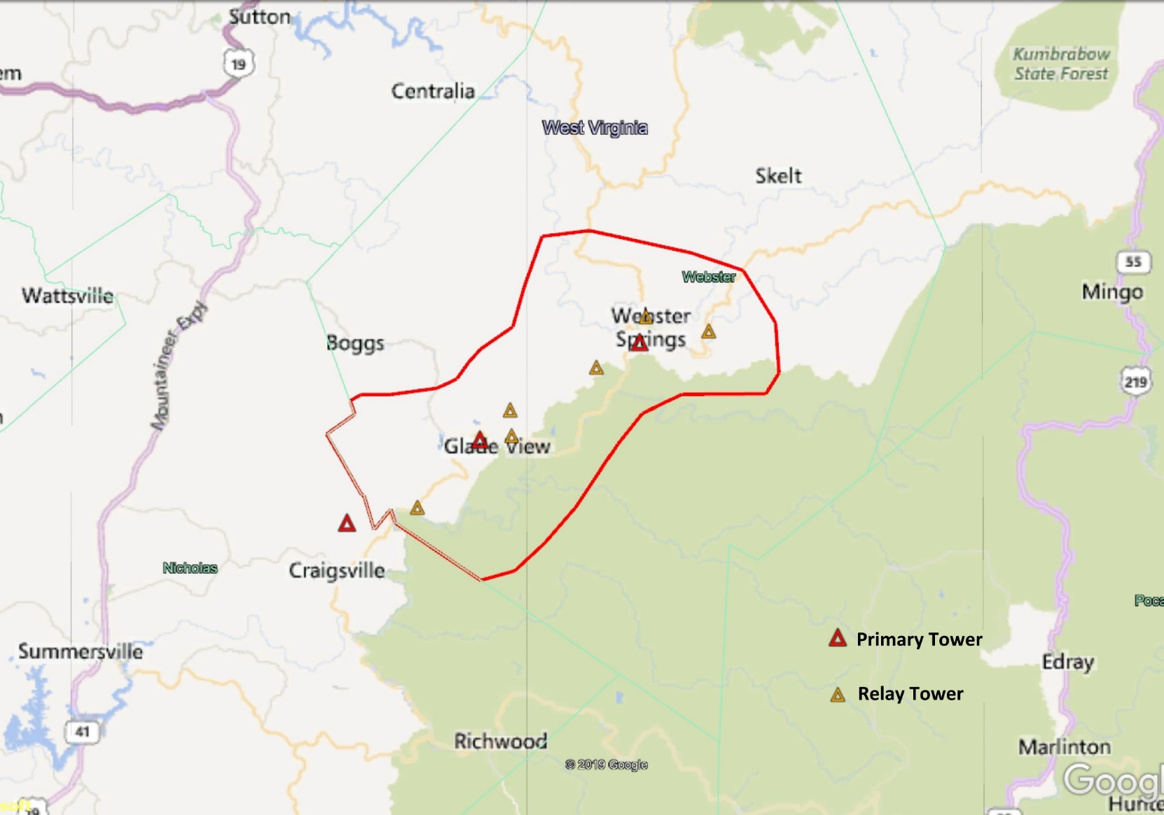

Preliminary Project Layout
_____________________________________________________________________________________________

